Sterilization
You want to sell foreign assets, but you do not want to change the domestic monetary base. CB buys domestic assets (government bonds) for $100 (deposits for who sells)=> total A and L are unchanged, but composition of A changes.

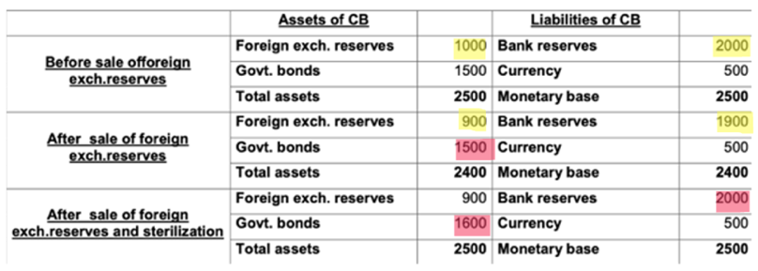

Open Market Operations
Recall Liabilities of the cb = MB = MS
If The central bank sells 100$ foreign asset receives 100$ worth (currency if pays cach, bank reserve if pays with a check. oui oui, but what if foreign buyer? c’mon obv he has to convert before!) => MS $↓$ by 100.
Why buying and selling foreign assets? to change the relative value of currencies

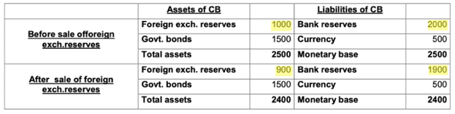

Title: FE
Subject: MACRO 7

BoP: CA + KA = FA => CA + KA = δNFA private sector + δNFA cb (BoP: official settlment of balance)

Change in country Net foreign Assets
Change in Cb NFA

+ purchase foreign A – purchase dom A by foreign cb

change of Monetary Base, if not sterilized
Imagine: output increases => D for money up =>
R should increase => CB must intervene to increase
Ms (buy foeign or domestic assets)

Pegged Exchange Rate: To hold E constant, cb needs enough reserves to trade currencies at the fixed exchange rate with the private actors in the FE mkt.
When the exchange rate is fixed at E⁰, UIP R = R* => MP becomes endogenous, no longer independent, you import the MP of the foreign country. But fp becomes more powerful (it does not cause appreciation / deprecitionof exchange rate). This means money supply mjust be automatically adjusted st the money mkt eq is maintained at R = R* <= endogenous

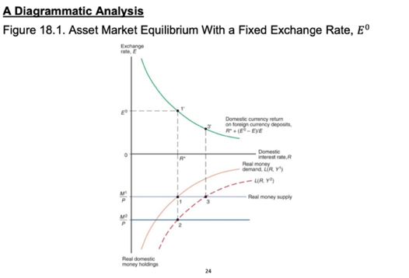

MONETARY AND FISCAL POLICY, TEMPORARY AND PERMANENT, FLOAT VS PEG

PEG
FLOAT
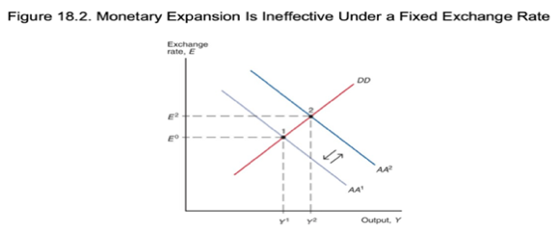
A1. Temporary Monetary expansion (no effect on Ee)
Imagine CB tries an OMO to increase Ms
(buy domestic asset )=> downward pressure
on i => to prevet current depreciation CB
sells foreign assets. Same M^{S} but different
composition (like a sterilized intervention)
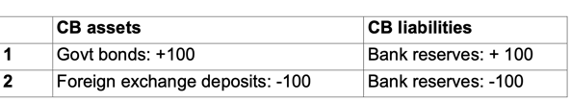
RER: changed in sr, unchanged in lr

MP
A1. Temporary Monetary expansion (no effect on E^{e})
MS increase => i ↓ => for the same y, E ↑
(Ee is fixed) =>AA shift. Home products are cheaper
=> higher AD (prima finisci in 3, poi la produzione si
muove). Temporary! (How? find below!)

RER: Changed in S

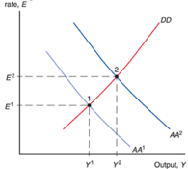

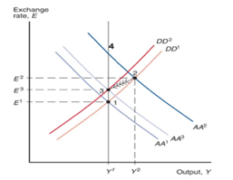
A2. Permanent Monetary expansion (no effect on Ee) = Devaluation

A2. Permanent Increase in the M^{S} (Ee affected)
i. Expansionary shift in money supply =>
=> i ↓ => for the same y, E ↑ =>AA shift (If
permanent shifts even more due to E^{e})
i. In the SR not in 2 but “vertically” to 4
ii. excess D for goods ( you are left of DD!) bc E $↑$
=> prod accommodate extra demand, Y2
iii. P $↑$: the AA curve shifts $↓$(real money supply $↓$) + DD curve shifts $↑$ (less exports competitive). P will adjust until they reach the non-inflationary level , progressive adj.
iv. we reach point 3, still at full employment but with a more depreciated E
Note the overshooting!
RER: Changed in Sr, Unchanged in LR

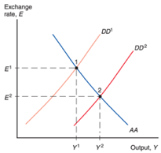
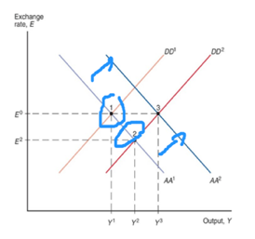
B1. Temporary Fiscal expansion
Higher G => Higher Y (DD shifts)=> higher need
for money => higher i => AA shifts
appreciation. Temporary!
RER: Changed in SR

FP
B. Fiscal Policy
G up => DD $↑$ would increase R => E $↓$
=> CB must increase MS (buy domestic or foreign
assets) to take R back to R*. In flex you would simply
go to 2. Note Fiscal policy is very powerful in the peg
(y3 > y2), bc cb keeps E fixed => no CA crowding out.
RER: UNCHANGED IN SR

In the LR, the final effect is equal to the flex effect: Y3 > Yn => P $↑$ => exports $↓$ DD shifts left, lower real Ms AA =>Y returns to initial level (so both curves back to initial pos). WOOOO price increase with fiscal poliy?? NO!! it’s monetary policy! Regardless of whether E float or fixed, the RER appreciates in the LR by the same amount, before due to E, now due to P
Perchè Y = YN con RER apprezzato? IT’S A PERMANENT SHIFT IN DEMAND, IN PREFERENCES, YOU HAVE IT IN 9, RESPONSE MUST BE NECESSARILY A CHANGE IN RER!

RER: UNCHANGED IN SR AND LR

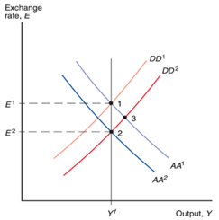
B2. Permanent Fiscal Expansion (E^{E} affected)
G increases => DD curve shifts to the right.
This causes a permanent shift in D towards
domestic goods => E^{e} appreciates in the LR
=> AA shifts left. Overall same Y (export
crowd out compensates G increase),
but more appreciated E.
RER: CHANGED IN SR AND LR

*Nota: devi pensare l’espanione in Y2 come immediata.
Countercyclical MP for temporary shocks(monetary shock and fiscal shock)

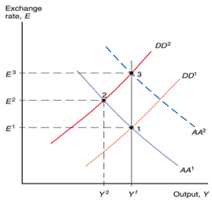
Ex.1Fall in world D for your exports:
DD shifts left => Y $↓$, we move along the AA. No shift in AA
bc E^{e} does not change as the shift temporary.
Two options
- CB will increase Ms to lower i and to restore Yn: i down =>
E $↑$=> home products are now cheaper => higher AD (higher Y).
- Expansionary fiscal policy
=> MP created depreciation, FP does not!

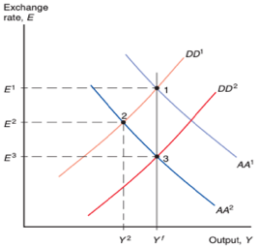
Ex.2 increase in demand for money
i up, E down => AA shifts down.
- MP back to Yn and no depreciation.
- FP back to Yn but depreciation!

\

Bop Crises

- SR: A devaluation occurs in a peg when the cb raises the domestic currency price of foreign currency, E. All the central bank has to
do to devalue or revalue is announce its willingness to trade domestic against foreign currency, in unlimited amounts, at the new exchange
rate. So imediatelly after the announce you have E1 Y1 (Il primo shift di AA è E expected), then since there is excess demand output adjustes expanding towards the right, as Y expans Md increases, Ms increases (AA shifts) to avoid appreciation.. Same final result as the sr flexible, but in Flexible first Ms expansion then E depre. Here first you devalue than you expand.
In the LR same effect as float: proportional increase in P and Ms To offset increase in E. No effect on RER on LR or Y., both AA and DD shift back, but no overshooting

A devaluation It’s a way to recover the power of monetary policy.
1. A devaluation allows the government to fight domestic u by boosting AD.
2. The CA improves.
3. If the cb is running low on reserves, a sudden, one-time devaluation can be used to draw in more reserves. Three reasons for this:
- First, if the exchange rate devalues by X % a given amount of cb assets denominated in foreign currency, once expressed in domestic currency, increases by X percent.
- Second, after a devaluation, domestic assets are cheaper once expressed in a foreign currency => foreigners buy domestic assets (assuming no future devaluations)
- Third, your exports are cheaper, you sell more goods and services

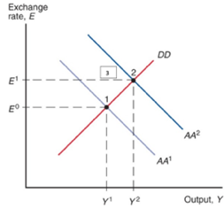

Mechani

Abandon the peg: balance of payment crises and capital flights
Until now, we assumed that in a peg participants in the FE mkt believe E, in reality peg is not taken for given ex. due to nation running short on foreign reserves, or it is facing high domestic unemployment, or debt monetization. However, the market's belief in an impending devaluation can give rise to a bop crisis, i.e. a sharp decline in official foreign reserves sparked by a change in expectations about the future exchange rate (run on the CB)

i. At t0: Imagine suddently, due to a deterioration in the CA / cb running low on foreign reserves / other, agents expect the cb will devalue in the future and adopt a new fixed exchange rate E^{e}, E1 > E0 => upper panel: rightward shift.
ii. But we need E0 because we are in a peg, equilibrium (point 2') would require a rise in the domestic interest rate to R* + (E1 - E0)/E0. E should depreciate but is kept fixed.
iii. But imagine the cb does not devalue, rate remains at R*. Ppl (both home and foreign) want to sell domestic A and buy foreign A (Capital flight, both from domestic and foreign agents) => excess D for foreign currency deposits (capital flight). To continue holding the exchange rate at E0, the cb must defend the rate by selling reserves => M^{S} will fall => higher domestic rate. Now, there are two possibilities:

La riduzione nella Ms è un ‘effetto collaterale’ della difesa del peg! (scrivo questo perchè poi vedremo che la cb puà cercare di alzare il tasso per bloccare l’outlfow)

Cb has enough reserves to fight

Once MS has fallen to M2, the money market is in equilibrium at the new interest rate R* + (E1 – E0)/E0 (point 2).
The higher the expected devaluation the higher the needed reserve loss and the interest rate increase (higher p of recession).

Cb finishes reserves (ho scelto io di separare per collegare al timing)

If the cb finished reserves must cede to mkt and devalue.

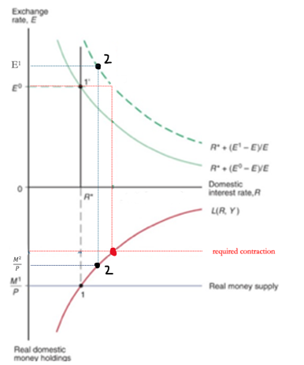

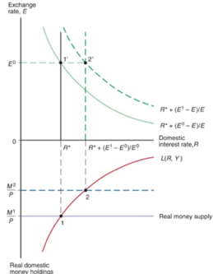

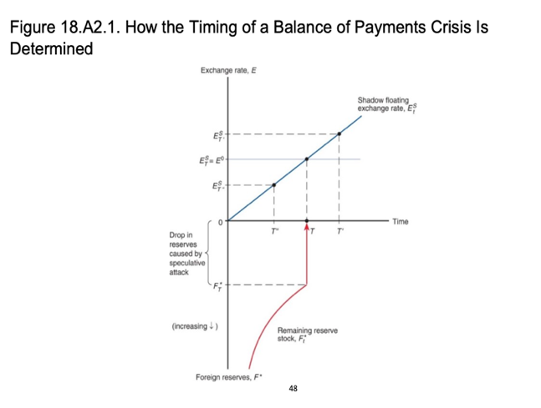
Timing of a bop crisis.
Imagine cb is pursuing debt monetization:
constantly Cb buys domestic assets sells foreign reserves (no change in Ms, sterilized). Here foreing reserves are declining not bc agents are rushing out, but due to debt monetization! Shadow exchange rate depreciates at the rate of growth of the domestic Ms.

At t When shadow reaches official: you have a run => discrete decrease in reserves.
Suppose at T' > T: expect a depreciation => would run before You will never want to hold an asset that you expect to be devaluated.
Suppose at T'' < T: expect an appreciation => would not make a run, but the opposite
At T: before we had national cb doing sterilized debt monetization, now you have huge outlow, cb tries to fight, but does not manage (finishes reserves ) => Money supply declines, but money demand also falls as the interest rate rises by expected depreciation (recall that after devaluation money supply keeps rising at fixed rate: recall also that E expected in UIP is E expected t+1)

* Shadow exchange rate: exchange rate that would prevail if CB allowed
exchange rate to float and had no foreign
reserves.

All of this is sterilized! no change in Ms

This is Ms loss. If GOES TO 0 = INSUFFIEICENT!

Solution: solve structural problems (no monetary financing) or increase domestic interest rates drastically (before R up was a physiologic consequence of fighting, now you do it on purpose!) so as to make it very costly for speculators to take a position against the domestic currency (partial solution, structural problem will remain). Is struct problems are not solved fighting just postpone the collapse, it arrives but more slowly.
SE VUOI ALZARE I A SUFFICIENZA PER DIFENDERE DEVI RIDURRE MONEY SUPPYL DELLO STESSO AMMONTARE CHE PORTAVA R CON IL COBATTIMENTO UTILIZZANDO LE FOREIGN RESERES

Self-fulfilling Balance of Payment crises
Not all crises are of this kind, however. An economy can be vulnerable to currency speculation even without being in such bad shape => self-fulfilling currency crises. Same mechanism of a bank run, excepts that the run is on cb instead of a normal bank. If an investor believes that the cb will devalue, she will want to convert her domestic assets into foreign assets before. All investors will do the same thing => speculative private capital outflows.
Extra: How to speculate against the currency of country A:
- borrow 10 units of currency A at interest iA
- Convert A into B at a given exschange rate (cb A loses foreign exchange reserves). if exchange rate is 2 (2 currency B for 1 unit of currency A) => you have 20 B
- Buy B deposit, which gives interest rate iB, where iB < iA (why? mkt expects devaluation of A, so interest by UIP interest rate on A must be > on b)
- wait for devaluation (hope as soon as possible)
- Once currency A has devalued, convert the B deposit back into currency A. If the new parity is 1 (1 unit of currency B for 1 unit of currency A), this gives 20 units of currency A (plus interest), against the 10 units he started with
=> gain – interest on amount borrowed. Note: not all speculator end up profiting => fight speculators vs CB => if cb wants to fight back (for credibility) it has to raise ia massively! => speculators pay huge i on money they borrow. high Ia can happened for sort: cb is having hugse foreign reserves losses and econ is dying. ex. Sweden fought back 500% iA (annaluzed), uk 1992 did not managed to resist (6 bn £ in foreign resrves spent).

F. Is sterilized intervention really does not change M^{S} => i?
Add risk:
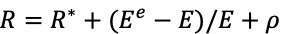
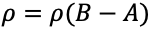
Positive relation. B = total nat debt, A = amount of gov debt in hands of CB. riskiness of the dom asset $↑$with its supply to the private sector! Terrible example:
Imagine you are buying a foreign asset and selling a domestic
one => ρ up! => imagine you are at E = Ee => R = R* +(Ee – E)/E + ρ. => Given R, R* and E^{e} fixed, if ρ $↑$ exp return on foreign deposits must $↓$ => ((Ee – E)/E) ↓ expected depreciation↓ = this happens if E ↑ = current exchange rate depreciates now! => UIP up! You managed to depreciate even without chnging E and i

B. Yes in A model of imperfect substitutability

A. NO in Basic model of perfect substitutability
Sterilized interventions ineffective in changing E as there is no change in overall quantity of Ms, just composition.
Why? basic model assumes perfect asset substitutability: In a world of perfect asset substitutability: same risk for domestic and foreign assets, we care just about retuns = determined by money supply.

So cb expands Ms by buying domestic assets, then to keep E fixed has to sell foreign assets domestic assets! No effect overall

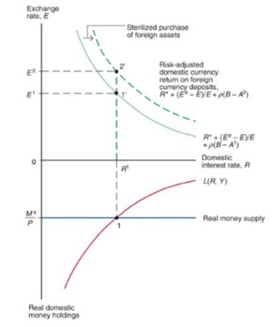

Suppose gov performs sterilized intervention (buy domestic assets and sell foreign ones!)
by buying 100$ gov bonds and selling 100$ foreign assets
=> A up => ρ down! As UIP with peg + risk premium: R = R* + ρ => R decreases! you managed to expand even without changing E! => under imperfect asset substitutability, the exchange rate and monetary policy can be managed independently through a sterilized intervention!

Demand for reserves: why do you need reserve

1. CA health
Cb monitored variability of exports and imports and measured reserve levels in terms of the number of months of import needs those reserves could cover (the higher variability the more the reserves needed)

Cb hold int reserves bc they can be traded to foreigners for goods even in circumstances, such as financial crises and wars, when the value of domestic assets may come into doubt. Reserves are crucial: cbs and govs may alter their policies to increase them.
Main cost of holding reserves: lower interest rate on reserves (domestic interest rate likely to be higher).How many reserves do you need?

2. Opennes
cb considers the adjustment costs countries would suffer if they suddenly had to raise exports or reduce imports to generate a trade surplus, or raise interest rates to draw in foreign capital. Higher economic openness could make such adjustments easier, D^{R} $↓$ but might also make an economy more vulnerable to foreign trade shocks, thereby raising desired reserve holdings.

Trends in demand for reserves
In the 1960s many predicted that move to flexible exchange rate would reduce D for reserves, because a country with flexible exchange rates would find it easier to generate an export surplus if reserves ran low, by allowing the currency to depreciate. This did not happen:
- For industrial countries, the growth rate of international reserves has remained positive since the 1960s.
- For developing countries, the growth rate of reserves has been high on average over the past four decades (the sharp upsurge in the mid-2000s is to some degree a reflection of huge reserve purchases by China).
Possible explanation:The growth of global capital markets has vastly increased the potential variability of financial flows across national borders.

Note the sharp decline in developing-country reserve growth in the 1982–1992 period. In that crisis, foreign lending sources dried up, forcing many developing countries to draw on their reserves.

Becoming a reserve currency is crucial:
Politically prestige: ex for Modi’s India
Economically:
- you do not have to borrow in foreign currency (latin America recall)
- lowers your financing cost and interest rate
- You need to hold less foreign reserves
- A stable currency fosters international investment (private and institutional portfolios)
- you can set import and export prices in own currency (no exchange rate risk for exporters and importers).

Why dollar still reserve currency? being big not suff., need to be open!
- Eu is fragile and soverieng debt market is fragmented
- China: Capital controls maniupation, limited convertibility. But is building an alternative SWIFT system proving that counties (ex. Russa) cam circumevent the dominant doallr system if they want to.
+ Dollar has strong network effects

BUT Huge econ not necessarily reserve currency (yuan 3% of total (0.6% if you do nto consider HK) even if China is 17% of global GDP). Why= you need to open up Capital account, eliminate capital controls, show currency is stable. Ex Japan: in 1970 1% of Japan exports were invociced in Yen, in the early 80s 40% as they removed capital controls. Need is to be very open: open up CA and capital account, eliminate restictions, show currency is stable => distrupted Japanese export led economy (Yen appreciation as foreigners tarted buying Japanese assets)

BoP

Recall Notation 1: CA (exports of goods - imports)= - FA (-(exports of k – imports of k)), since CA = dNFA => dNFA (accumulated assets) = - FA

So an increase in the FA implies a reduction in assets, in fact: buy a car with deposit => export of k. CA-, FA+, losing Assets -dNFA (deposit).

